CS 255 System Design Document Template

UML Diagrams

UML Use Case Diagram:

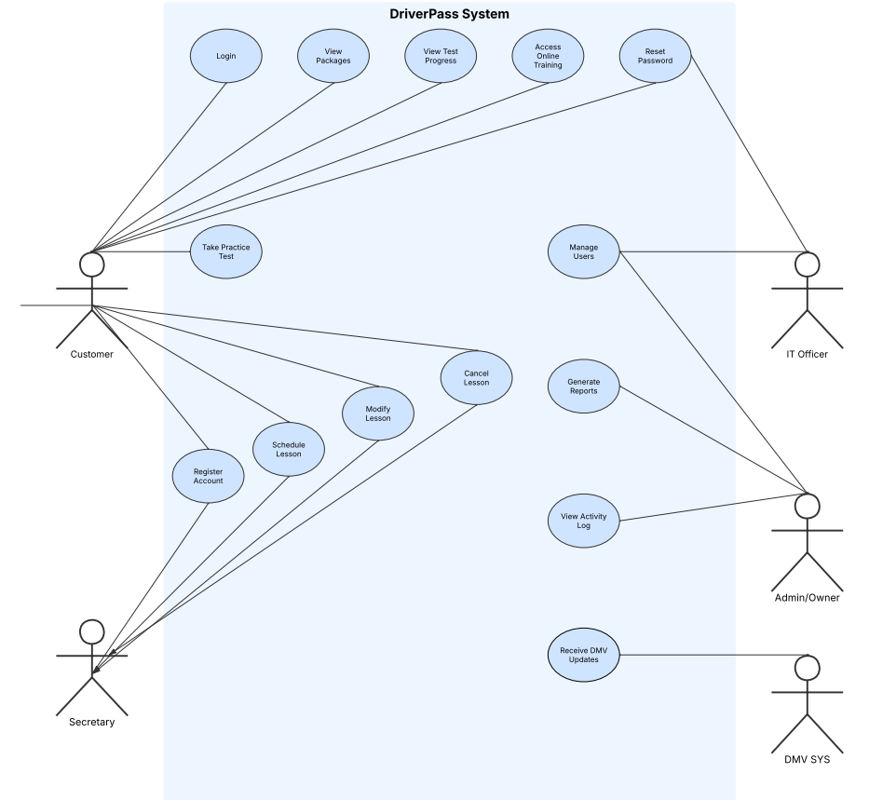

The use case diagram shows how different users interact with the DriverPass system. It highlights the main system functions such as account management, lesson scheduling, and administrative tasks.

UML Activity Diagrams: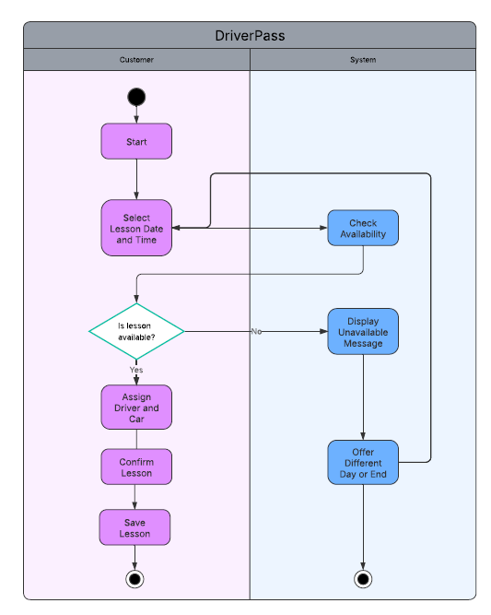
This activity diagram illustrates the login process. It shows how the system validates user credentials and either grants access or provides error handling with a password reset option.
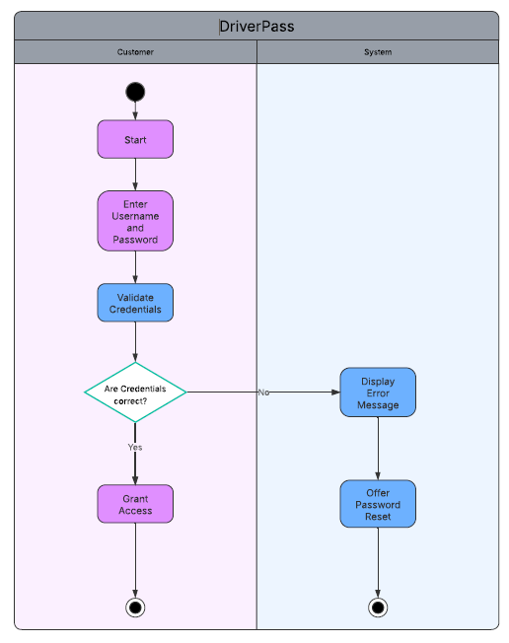
This activity diagram shows how a lesson is scheduled within the system. It includes selecting a time, checking availability, assigning a driver and vehicle, and confirming or retrying the booking.

UML Sequence Diagram:
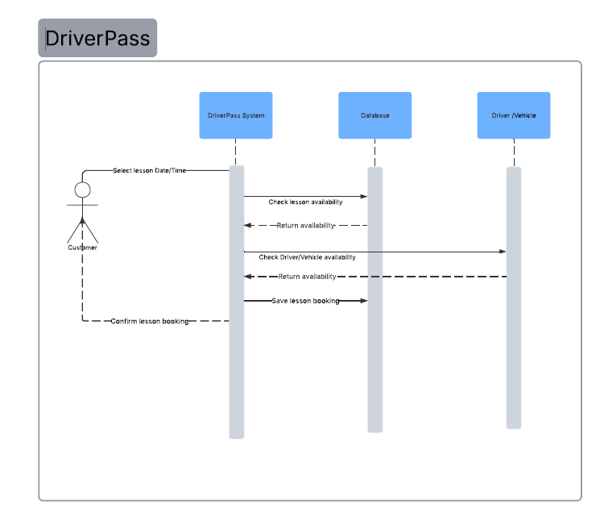
The sequence diagram demonstrates how different components of the system interact when scheduling a lesson. It shows the order of communication between the customer, system, database, and lesson resources.

UML Class Diagram:

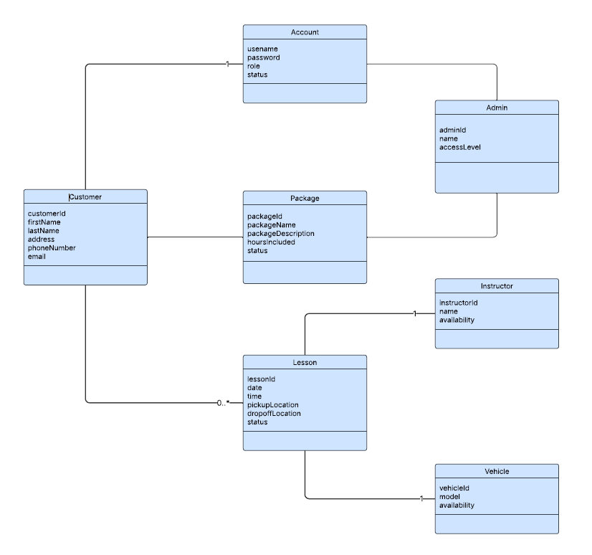

The class diagram represents the structure of the DriverPass system. It defines the main classes, their attributes, and how they relate to one another to support scheduling, account management, and system administration.

Technical Requirements

The DriverPass system will be a web-based application that can be accessed from multiple devices, including desktops, laptops, tablets, and smartphones. Since the system is cloud-based, users will not need to install any software locally, and the system will be accessible through a standard web browser.
The system will require a server environment to host the application and database. A cloud platform such as AWS or a similar provider would be ideal, as it allows for scalability, reliability, and reduced maintenance. The database will store customer information, lesson schedules, account details, and system activity logs.
From a software perspective, the system will use a backend framework to handle business logic, user authentication, and scheduling functionality. The frontend will provide a user-friendly interface for customers, staff, and administrators to interact with the system. Security features such as role-based access control and encrypted data transmission will be required to protect sensitive information.
The system will also require tools for development and maintenance, such as version control (GitHub), testing tools, and monitoring services. These tools will help ensure the system runs efficiently and can be updated as needed.

